**IELTS Vocabulary for Maps (Listening)**

**Common Problems**

* Students need to come across too much information. Moreover, they are required to be aware of directional language, understanding the diagram and note taking, all at the same time.

​

* Creating mental visual image of a description is very challenging in case of a very unfamiliar topic. Whereas if you fail to visualize, it might be very difficult for you to answer this question.

​

* Only because of spelling error, many students throw away a lot of marks in this question. It happens because in the listening section you need to do so many tasks at the same time when you are answering this question.

​

* There are some common useful vocabulary that are used in this type of question. If you don't know these contextual expressions, answering this question might be a very challenging task for you. Check the useful expression list below:

**Common Expressions for diagram/plan labeling**

North/South/East/West

* inside/outside
* left-hand side/right-hand side
* a little ahead/forward
* just before you get in/to
* runs beside/alongside
* enter through/via
* southeastern/northeastern
* in the southeast/in the northeast
* above/below
* in front of/opposite to
* clockwise/counterclockwise/anticlockwise etc.

At the top / at the bottom

On the left / on the right

Left hand side / right hand side

South / North / East / West

Southeast / Southwest / Northeast / Northwest

To the north / to the south / to the east / to the west

Opposite  / in front of / behind

In the middle / in the center

Above / below

Inside / outside

Just beyond / a little beyond / just past

Next to / alongside / adjoining (= next to or joined with)

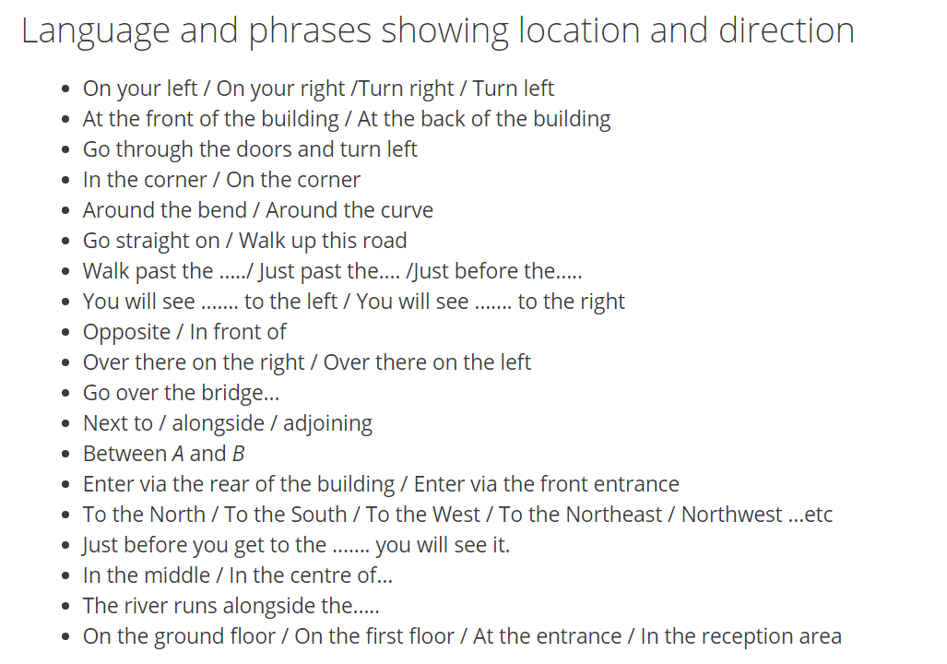

#### IELTS Listening Map Vocabulary – Set 1

* **facing**
* **in the middle / centre of**
* **behind**
* **between**
* **next to / by**
* **in front of**

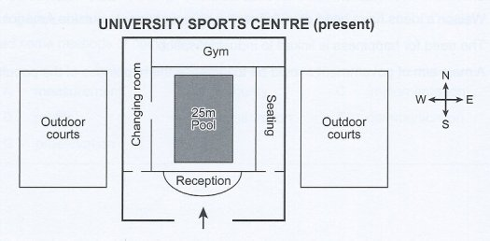

                              Source: Cambridge English past paper

The entrance is **in front of** the reception desk.

The reception desk is **facing** the entrance.

The pool is **in the centre of** / **in the middle of** the sport’s centre.

The gym is **behind** the swimming pool.

The pool is **between** the reception and the gym.

The seating area is **next to** / **by** the pool.

#### IELTS Listening Map Vocabulary – Set 2

* **left-hand side**
* **right-hand side**
* **turn right**
* **to your right**
* **pass through**
* **on the other side**
* **beyond**
* **along**
* **corner**
* **go straight**
* **beside**

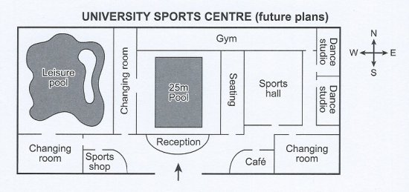

                              Source: Cambridge English past paper

The sports shop is on the **left-hand side** as you enter the sports centre.

To the **right-hand side** of the entrance, there’s a café.

**Pass through** the entrance, **turn right** and the café is immediately **in front of** you.

The leisure pool is **on the other side** of the sports centre to the dance studios.

There is a large changing room just **beyond** the café.

Walk **along** the side of the sports hall and you’ll find the second dance studio in the far **corner** of the building

**Go straight** along the corridor **beside** the sports hall and **to your right**, you’ll see two dance studios.

#### IELTS Listening Map Vocabulary – Set 3

Maps nearly always have compass points shown. You need to know the 8 points of the compass as these are often used in the recording to describe position. The 8 points are:

* **north**
* **south**
* **east**
* **west**
* **northeast**
* **northwest**
* **southeast**
* **southwest**

There are several different ways you might hear them used.

* **to the north / to the south …**
* **in the northeast / in the southwest …**
* **north side / east side / west side / south side**
* **heading east**
* **slightly west of**
* **just southeast of**

Other vocabulary:

* **near**
* **first / second turning**
* **on the left**
* **straight ahead**

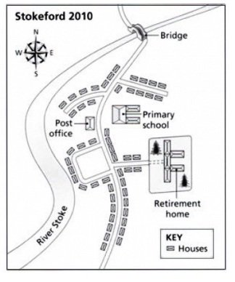

                              Source: Cambridge English past paper

The houses immediately **to the north** and **south** of the Post Office are very **near** the river.

The bridge is just beyond the final row of houses **heading north**.

After crossing the bridge, take the**second turning** **on the left** and you’ll see the retirement home **straight ahead**.

The retirement home is **just southeast** of the primary school.

The post office is **to the northwest** of the retirement home.

The village of Stokeford is **slightly east** of the River Stoke.

There is a housing estate to the **west side** of the retirement home.

#### IELTS Listening Map Vocabulary – Set 4

* **opposite**
* **across the road**
* **same side**
* **before you get to**
* **junction**
* **dead end**
* **leads off**

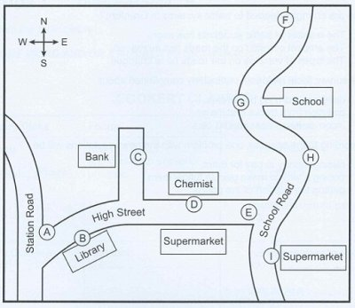

                              Source: Cambridge English past paper

The chemist is **opposite** a supermarket.

They are going to build new houses **across the road** from the school at point G.

There is a supermarket on the **same side** of the road as the library.

Walk west along High Street and you’ll pass the library **before you get to** the **junction** with Station Road.

The bank is on a **dead end** road that **leads off** the High Street.

#### IELTS Listening Map Vocabulary – Set 5

* **bend**
* **just past**
* **alongside**
* **adjoining**
* **carry straight on**

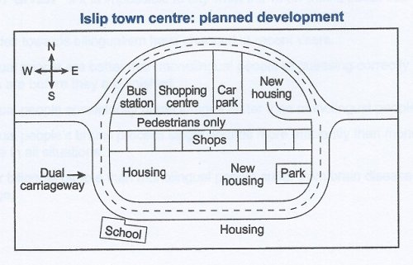

                              Source: Cambridge English past paper

The school is situated on a **bend** in the dual carriageway.

The bus station is on the right **just past** the shopping centre.

The town centre has a pedestrian walkway running **alongside** a row of **adjoining** shops.

After passing the school on your right, **carry straight on** and you’ll see the park on your left around the next bend.

**Solution Tips**

* Read the instruction sentence carefully and try to understand and then predict the answer before you start hearing the clip.

​

* The word that you need to answer might be a location, a building, a direction, an adjective, a verb, an adverb etc. Try to predict the type of word that you might need for your answer.

​

* Try to visualize the scenario. Put yourself into the audience's position who the speaker is describing to.

​

* Make sure you listen carefully the beginning of the recording. Because beginning part is very important to understand the topic. If you get it, it will be pretty much easy for you to follow the audio.​

​

* Focus on the major parts of the map/plan where the main directional or navigational languages are used.

​

* Take short notes in your own style whatever you are comfortable with. There is nothing wrong writing and taking notes on the question paper.

### Tips for IELTS Listening Map Labeling

1. Read the instructions carefully - this is so you know what you need to do and the maximum number of words and / or numbers you can use – in this case it is no more than two words.
2. Know the vocabulary of location - you need to know words commonly used to describe where things are located (see below).
3. Identify where the numbers start and finish – as you can see from the example, the first one (15) starts at the bottom, not the top. The numbers (15, 16, 17) will follow the order of the listening.
4. Understand the context - listen carefully at the beginning as the speaker will give you the context. (where you are for example) which will help you follow the talk. Also, look over the map. This will help you identify exactly what you are labelling - note the things that are already labelled to get a feel for where things are.
5. Predict the answers - as with all the listening test, it helps to predict what the answer may be. Look at the gaps and see if you can guess what you are labelling - a room, building, sports facility, street etc?
6. Pay particular attention to things close by - for example, number 15 is by the ‘station’ so it is quite likely (though not definite) that this will be mentioned just before number 15
7. Pay attention to any other clues in the map - for example, you are given a compass icon in the corner telling you where ‘North’, ‘South’, ‘East’ and ‘West’ are. This means it is likely that these phrases will be used to direct you. So listen out for them. You are also given your location - in the tower.
8. Look at two questions at once - this is something you should always do in the listening test. If you hear the answer to question 16, you will know you missed 15. Forget about this and move on. If you are only looking at 15 you could miss both and get lost.

Note:

* ONE WORD ONLY

You are only allowed to enter one word. For example, if you enter “a pen” your answer will be wrong, you have to write “pen”

* ONE WORD AND / OR A NUMBER

Your answer may be a word, a number, or a word and a number. For example: September, or 12th, or 12th September

* NO MORE THAN TWO WORDS AND / OR A NUMBER

Your answer may be one word, a number, a word and a number, two words, two words and a number. For example: 15 Bank Road. If you see this guide, most of the answers are two words or two words and a number.

* NO MORE THAN THREE WORDS

Your answer can be one word, two words or three words. If you see this guide, most of the correct answers are three words.

* Right next to the washroom **_**
* Beside the river **_**
* At the riverfront **_**
* The furthest away from the river **_**
* In the center of the camp **_**
* Right in the middle of everything **_**

Practicing Link:

https://tricksmagical.com/ielts-listening-map-plan-labinging-tricks-magical.html